B
=[irla Institute of Technology & Science, Pilani
Work Integrated Learning Programmes Division
First Semester 2020-21
M.Tech. (Data Science and Engineering)
Midsem Examination (Regular)

SOLUTION

Course No. : DSECLZG524
No. of Pages = 4
No. of Questions = 5
Course Title : DEEP LEARNING
Nature of Exam : Open Book
Weightage : 30%
Duration : 2 Hours
Date of Examination : November 1, 2020 Time of Exam: 10 AM – 12 PM
Note: Assumptions made if any, should be stated clearly at the beginning of your answer. Show your rough work to get partial credit, when appropriate.

Question 1. [1 + 1*2 + 2 + 1 =6 marks]
Consider the following DNN for image classification for a dataset that consists of RGB images of size 32x32.
model = models.Sequential()
# Layer 1
model.add(layers.Dense(50, activation='relu',input_shape=**A**))
# Layer 2
model.add(layers.Dense(40, activation='relu'))
# Layer 3
model.add(layers.Dense(30, activation='relu'))
# Layer 4
model.add(layers.Dense(**B**, activation=**C**))
model.compile(optimizer = 'sgd', loss = **D**, metrics=['accuracy'])

- What is the input shape **A** in Layer 1? (32*32*3,) or (3072,)
- What will be the value of **B**, activation function **C** and loss **D** if the total number of classes in the dataset is
- 2 1, sigmoid, binary_crossentropy
- 10 10, softmax, categorical_crossentropy
- What will be the total number of parameters in Layer 1, Layer 2 and Layer 3? If a dropout layer of value 0.5 is added after Layer 2, what will be the change in the number of parameters?
Layer 1- 3072*50 + 50 = 153,650
Layer 2- 50*40 + 40 = 2040
Layer 3- 40*30 + 30 = 1230
Total = 153650 + 2040 + 1230 = 156,920
No change in the number of parameters if dropout is added.

- What is the difference between kernel regularizers and activity regularizers?
kernel_regularizer: Regularizer to apply a penalty on the layer's kernel. activity_regularizer: Regularizer to apply a penalty on the layer's output.

Question 2. [3+3+1=7 Marks]
Refer to the following multilayer perceptron network with two hidden layers. All nodes use a step activation function, i.e.,
output = +1 if total input >= bias
output = -1 if total input < bias

Bias at each node is indicated inside the node.

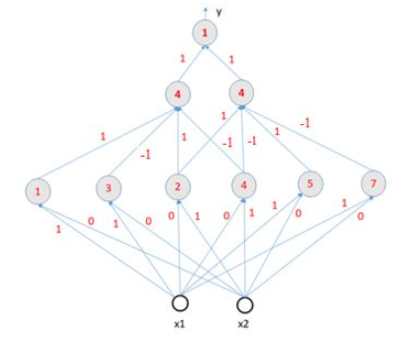
- What will be the output y, if (x1,x2)=(2,3), (x1,x2)=(6,3), and (x1,x2)=(4,3)
-1, -1, -1
- Express output y as a decision rule of input (x1, x2). Recall, decision rule is expressed as an if-then-else statement, e.g., y = (x1> 2) OR (x2 < 7) AND ( x1 + x2 = 7)
For any (x1,x2) total input to the outnode node is at most 0. So, y = -1
- Can this decision rule be realized using a multilayer perceptron with one hidden layer? If no, why? If yes, how many hidden node will be needed in that one hidden layer?
One hidden layer will be sufficient since output is always -1 irrespective of the input. One hidden node is enough. Actually no hidden layer is needed.
Question 3. [1+1+0.75*6=5 Marks]

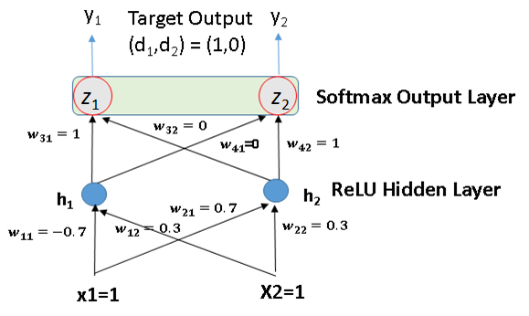

- Calculate the actual output (y₁, y₂) for the current iteration with input (x1, x2) = (1, 1).
y₁= 1 / (1+e) y₂= e / (1+e)
- With the (z₁, z₂) calculated in A., use the following computation graph to calculate the loss L, $\frac{δL}{δc}$ , $\frac{δL}{δd}$ $, \frac{δL}{δa} ,$ $\frac{δL}{δb}$ , $\frac{δL}{δz_{1}}$ , $\frac{δL}{δz_{2}}$ .

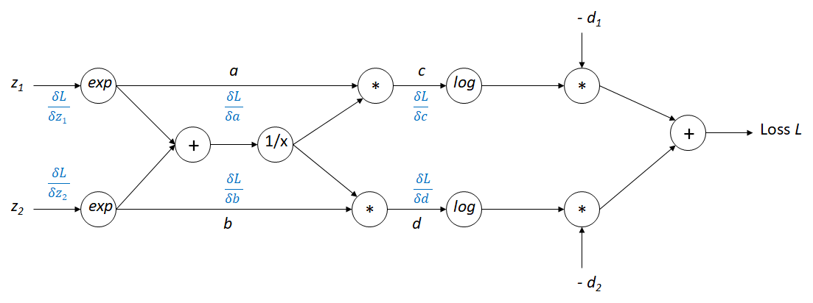
(z₁ = 0 z₂ = 1) L = - log(1/(1+e)) = log(1+e), a=1, b=e, c=1/(1+e), d=e/(1+e)
$$\frac{δL}{δc}=-\left(1+e\right) \frac{δL}{δd}=0 \frac{δL}{δa}=-\frac{e}{1+e} \frac{δL}{δb}=\frac{1}{1+e} \frac{δL}{δz_{1}}=-\frac{e}{1+e }$$
$$\frac{δL}{δz_{2}}= \frac{e}{1+e }$$

[Edit By Rohnak Agarwal, Generated by ChatGPT]
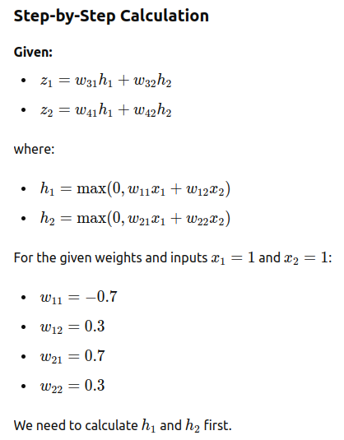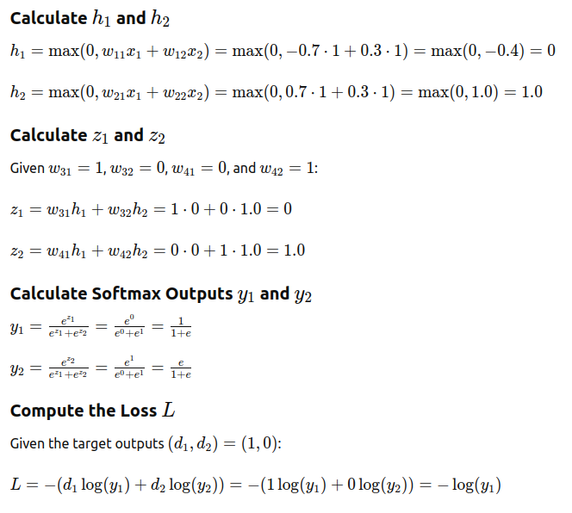
__________________________________________________________________________
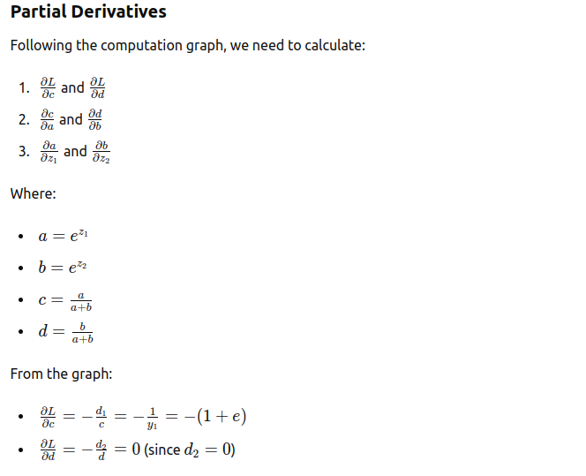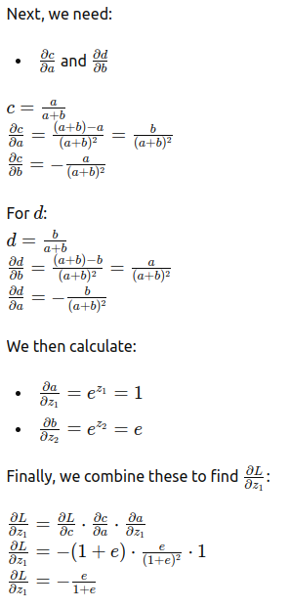

Question 4. [2+3+0.5+0.5 = 6 marks]

Consider the following training dataset with input X=(x1, x2) and target (desired) output d. A neuron with two inputs and one output is used for this training dataset. Activation function is a linear function with zero bias. Sum of square error is used as the loss function.

Input x1 | Input x2 | Target Output d
0 | 0 | 0.0
1 | 0 | 1.0
0 | 1 | 1.0
1 | 1 | 0.0

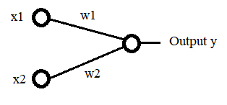

- If back propagation is used, what will be the weights (w1, w2) after convergence?
L = (w1-1)² + (w2-1)² + (w1+w2)² = 2w1² + 2w2² -2w1-2w2+2+2w1w2.
Components of Hessian H: h₁₁=h₂₂=4, h₁₂=h₂₁=2. Thus, H is +ve definite with a unique local minima. So, backprop will converge to that local minima and optimal (w1,w2)=(1/3,1/3).
- What will be the nature of the loss function? What is the value of learning rate which leads to convergence in least number of iterations? Show all calculation steps.
Loss function is quadratic, not oriented along either w1 or w2. Optimal learning rate is the 1/(largest eigenvalue of H). The eigenvalues of H are 2, 6. So, optimal learning rate for fastest convergence is 1/6.
- To achieve convergence in least number of iterations, will you use batch gradient descent, stochastic gradient descent or mini batch gradient and why?
Batch GD will converge in least number of iterations since it is convex loss function.
Question 5. [3+3=6 marks]
- Explain the effect with the reason for following operation on bias and variance of your model with “Increase”, “Decrease”, or “no change”.
Operation | Bias | Variance | Reason
Increasing the size of the hidden layer | Decrease | Increase | A larger hidden layer increases the model's capacity to capture complex patterns in the data, thus reducing bias. However, this also makes the model more flexible and prone to overfitting, which increases variance.
Using dropouts to train deep neural network | Increase | Decrease | Dropout is a regularization technique that prevents overfitting by randomly setting a fraction of the input units to zero at each update during training. This makes the model simpler and less likely to overfit, thus reducing variance. However, it can also lead to underfitting, increasing bias.
Getting more training data from same distribution | No change | Decrease | Increasing the amount of training data helps in reducing the variance of the model by providing a more comprehensive view of the data distribution. However, it does not inherently affect the bias of the model.
Regularizing the weights | Increase | Decrease | Regularization techniques like L2 (ridge) or L1 (lasso) penalize large weights in the model, leading to simpler models that are less likely to overfit the training data. This reduces variance but can increase bias by making the model less flexible and potentially underfitting the data.

- Performance of three optimization algorithms, momentum based gradient descent, RMSProp and ADAM are shown in different colors on the following loss landscape graph. Which color (green / purple / pink) represents which algorithms and why?
Momentum (Green):
- Momentum overshoots continuously.
- In the given loss landscape, the momentum reached the least cost with the minimum iteration.
- Momentum usually speeds up the learning with a very minor implementation change.
RMSProp(Purple):
- In the given loss land scape, smoother trajectory due to normalization with square of derivative of Loss.
- RMSprop has a faster trajectory in the initial iterations compare to ADAM as it uses only squares of derivative loss
- In the later iterations, the cost optimization is not much
- RMSprop maintains per-parameter learning rates.
- RMSprop’s adaptive learning rate usually prevents the learning rate decay from diminishing too slowly or too fast.
Adam (Pink)
- Adam performs a form of learning rate annealing with adaptive step-sizes.
- You can see a smooth but a slow trajectory though out the iterations.
- In the later part of iterations you can see the optimization works much better than RMSProp
- The hyperparameters of Adam (learning rate, exponential decay rates for the moment estimates, etc.) are usually set to predefined values, and do not need to be tuned.
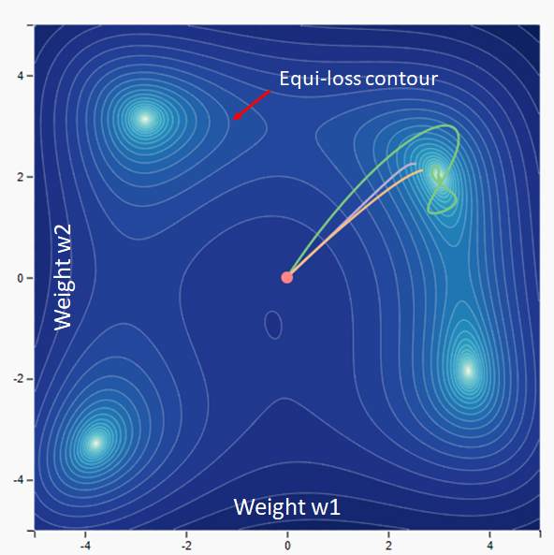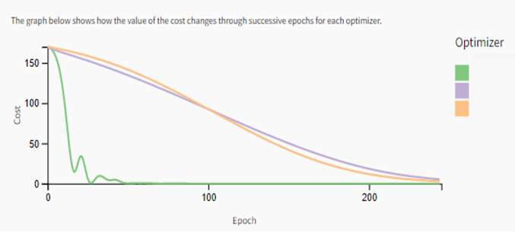

XXXXXXXXXXXX

